Digital Transformation for Educational Institutions.
Intranet Portal for Students, Parents, Teachers, and administrators.

An easy to implement solution built on Microsoft’s Office 365 platform, will help education institutions streamline processes. Improve data sharing across departments and ensure performance tracking at various levels – Students, Teachers, Institutions.

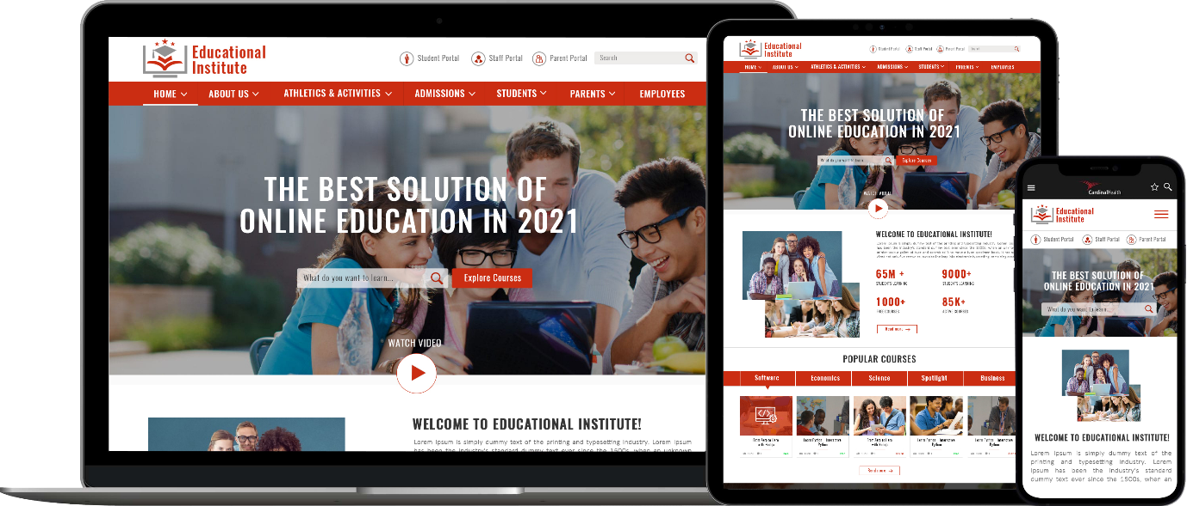

Clients

Customer Testimonials
The most impressive aspect of Binary Republik was the size of both their team and their knowledgebase.
Since they were onboarded all our projects have been delivered on time and on budget and at a higher quality. We can rely on the team's expertise when encountering a subject or obstacle they're unfamiliar with.
In many ways, they've become a trusted resource to our team. Whether it's providing advice on systems architecture, helping on projects, or anything in between, Binary Republik has been a valuable asset.

Student Dashboard - My Classes, My Assignments, Attendance Report & Results
As the name suggests, it allows students to access to all their relevant information consolidated at a single location. They can view their class schedule, track assignments, both current and past as well as make submissions for these assignments.

They can keep a track of their attendance reports, assessment schedule, view their current and past assessment reports and their various achievements. This section also allows them to view course specific resources uploaded by their teacher.

Teacher Dashboard - My Timetable, Teacher Announcement, Tasks, Current Assignments
Teachers can manage all their routine activities using Teacher Dashboard. They can set the Timetable, Assignments, Announcements, Subjects, and Tasks.

In Timetable, clicking on any class, will redirects them to that class and there they can perform attendance, provide homework, upload lesson plans, provide grades for behaviour and attendance. In the subject module teachers can see and update the curriculum. They can also upload files or references material for a specific topic or a module.

Parent Dashboard - Announcements, Notifications, Attendance Report, Test Results
Parents now have access to their children’s progress, all with a single click.
On Parent Dashboard, they can track the assessment reports, class schedules, announcements, home assignments and attendance reports.

They have access to comments and grades assigned on various assignments and tests. They can also see other details like the child's achievements, any behaviour issues, their report card, and subject materials that the teacher has added for assignment or curriculum.

This provides for seamless communication between the Institution and the Parents.

